 |  | Wash & Set | from | $20
 |  | Wash & Blowdry with Comb | from | $15
 |  | Wash, Set, Blowdry, Tong | from | $20
 |  | Wash, Cut & Style | from | $30
 |  | Wash, Set, Blowdry, Cut, Tong | from | $35
 |  | Conditioning Treatment | from | $35
 |  | Cut Only | from | $15
 |  | Trim only | from | $15
 |  | Ghana Braids | from | $40
 |  | Wave-on | from | $60
 |  | Tracks | from | $10
 |  | Braids (Cane Row) | from | $20
 |  | Bonding | from | $45
 |  | Dreadlocks | from | $70
 |  | Single Plaits | from | $65
 |  | Pick & Drop | from | $40
 |  | Straw Curls | from | $35
 |  | Texturizer | from | $40
 |  | Hair Relaxer | from | $40
 |  | Curly Perm | from | $45
 |  | 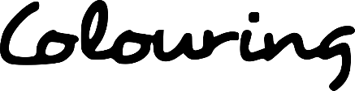
 |  | Semi-Permanent & Styling | from | $40
 |  | Permanent & Styling | from | $45
 |  | Full Head | from | $55
 |  | Half Head | from | $45
 |  | Brazilian Blowdry (Keratin) | from | $100
555 - 1800 - 999
Business Name
 |  | YOUREMAIL@YAHOO.COM
 |  | WWW.YOURWEBSITE.COM

