|  |  |  |  |  |  |  |
| --- | --- | --- | --- | --- | --- | --- |
| **Январь** | | | | | | |
| **Пн** | **Вт** | **Ср** | **Чт** | **Пт** | **Сб** | **Вс** |
| **1** | **2** | **3** | **4** | **5** | **6** | **7** |
| **8** | **9** | **10** | **11** | **12** | **13** | **14** |
| **15** | **16** | **17** | **18** | **19** | **20** | **21** |
| **22** | **23** | **24** | **25** | **26** | **27** | **28** |
| **29** | **30** | **31** |  |  |  |  |
|  |  |  |  |  |  |  |

**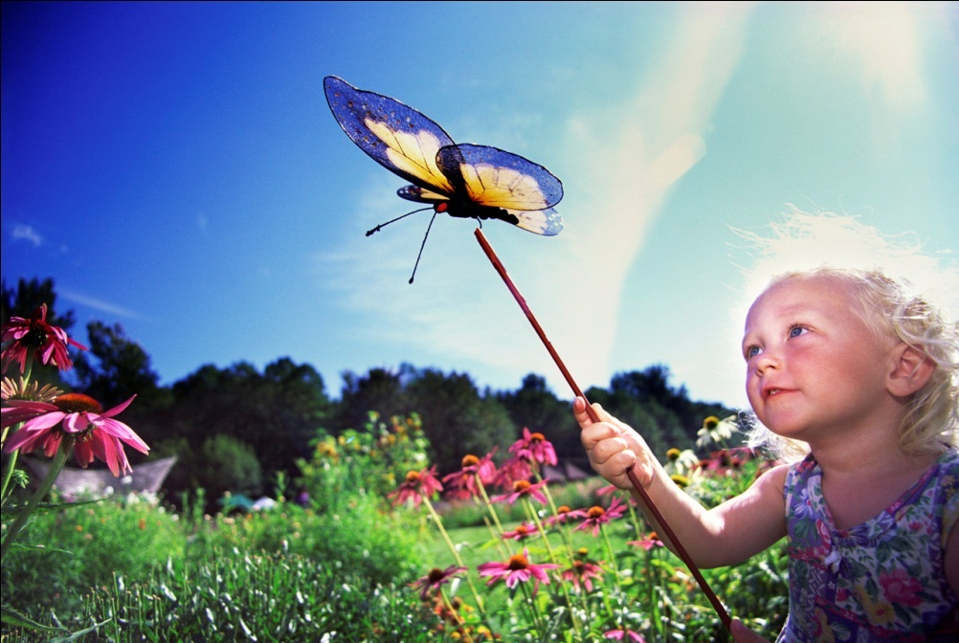x-mass 6**

j0232615C:\Anton\WRK\Microsoft\Calendar\materials\winter2.wmf

**winter**

|  |  |  |  |  |  |  |
| --- | --- | --- | --- | --- | --- | --- |
| **Февраль** | | | | | | |
| **Пн** | **Вт** | **Ср** | **Чт** | **Пт** | **Сб** | **Вс** |
|  |  |  | **1** | **2** | **3** | **4** |
| **5** | **6** | **7** | **8** | **9** | **10** | **11** |
| **12** | **13** | **14** | **15** | **16** | **17** | **18** |
| **19** | **20** | **21** | **22** | **23** | **24** | **25** |
| **26** | **27** | **28** |  |  |  |  |
|  |  |  |  |  |  |  |

****

**j0398425**

|  |  |  |  |  |  |  |
| --- | --- | --- | --- | --- | --- | --- |
| **Март** | | | | | | |
| **Пн** | **Вт** | **Ср** | **Чт** | **Пт** | **Сб** | **Вс** |
|  |  |  | **1** | **2** | **3** | **4** |
| **5** | **6** | **7** | **8** | **9** | **10** | **11** |
| **12** | **13** | **14** | **15** | **16** | **17** | **18** |
| **19** | **20** | **21** | **22** | **23** | **24** | **25** |
| **26** | **27** | **28** | **29** | **30** | **31** |  |
|  |  |  |  |  |  |  |

**1_spring**

**march_BG2j0232065**

|  |  |  |  |  |  |  |
| --- | --- | --- | --- | --- | --- | --- |
| **Апрель** | | | | | | |
| **Пн** | **Вт** | **Ср** | **Чт** | **Пт** | **Сб** | **Вс** |
|  |  |  |  |  |  | **1** |
| **2** | **3** | **4** | **5** | **6** | **7** | **8** |
| **9** | **10** | **11** | **12** | **13** | **14** | **15** |
| **16** | **17** | **18** | **19** | **20** | **21** | **22** |
| **23** | **24** | **25** | **26** | **27** | **28** | **29** |
| **30** |  |  |  |  |  |  |

**2_spring**

**2_spring_BGj0232429**

|  |  |  |  |  |  |  |
| --- | --- | --- | --- | --- | --- | --- |
| **Май** | | | | | | |
| **Пн** | **Вт** | **Ср** | **Чт** | **Пт** | **Сб** | **Вс** |
|  | **1** | **2** | **3** | **4** | **5** | **6** |
| **7** | **8** | **9** | **10** | **11** | **12** | **13** |
| **14** | **15** | **16** | **17** | **18** | **19** | **20** |
| **21** | **22** | **23** | **24** | **25** | **26** | **27** |
| **28** | **29** | **30** | **31** |  |  |  |
|  |  |  |  |  |  |  |

**C:\Users\Antonio\Pictures\Организатор клипов (Майкрософт)\j0232157.wmfC:\Anton\WRK\Microsoft\Calendar\materials\3_spring_BG.wmfC:\Anton\WRK\Microsoft\Calendar\materials\3_spring.wmf**

**C:\Anton\WRK\Microsoft\Calendar\materials\girl.wmfC:\Anton\WRK\Microsoft\Calendar\materials\4_summer.wmf**

|  |  |  |  |  |  |  |
| --- | --- | --- | --- | --- | --- | --- |
| **Июнь** | | | | | | |
| **Пн** | **Вт** | **Ср** | **Чт** | **Пт** | **Сб** | **Вс** |
|  |  |  |  | **1** | **2** | **3** |
| **4** | **5** | **6** | **7** | **8** | **9** | **10** |
| **11** | **12** | **13** | **14** | **15** | **16** | **17** |
| **18** | **19** | **20** | **21** | **22** | **23** | **24** |
| **25** | **26** | **27** | **28** | **29** | **30** |  |
|  |  |  |  |  |  |  |

**C:\Anton\WRK\Microsoft\Calendar\materials\4_summer_BG.wmf**

|  |  |  |  |  |  |  |
| --- | --- | --- | --- | --- | --- | --- |
| **Июль** | | | | | | |
| **Пн** | **Вт** | **Ср** | **Чт** | **Пт** | **Сб** | **Вс** |
|  |  |  |  |  |  | **1** |
| **2** | **3** | **4** | **5** | **6** | **7** | **8** |
| **9** | **10** | **11** | **12** | **13** | **14** | **15** |
| **16** | **17** | **18** | **19** | **20** | **21** | **22** |
| **23** | **24** | **25** | **26** | **27** | **28** | **29** |
| **30** | **31** |  |  |  |  |  |

**C:\Anton\WRK\Microsoft\Calendar\materials\6_summer_BG.wmfC:\Anton\WRK\Microsoft\Calendar\materials\5_summer_BG.wmfC:\Users\Antonio\Pictures\Организатор клипов (Майкрософт)\j0232053.wmfC:\Users\Antonio\Pictures\Организатор клипов (Майкрософт)\j0232649.wmfC:\Anton\WRK\Microsoft\Calendar\materials\4_summer.wmf**

|  |  |  |  |  |  |  |
| --- | --- | --- | --- | --- | --- | --- |
| **Август** | | | | | | |
| **Пн** | **Вт** | **Ср** | **Чт** | **Пт** | **Сб** | **Вс** |
|  |  | **1** | **2** | **3** | **4** | **5** |
| **6** | **7** | **8** | **9** | **10** | **11** | **12** |
| **13** | **14** | **15** | **16** | **17** | **18** | **19** |
| **20** | **21** | **22** | **23** | **24** | **25** | **26** |
| **27** | **28** | **29** | **30** | **31** |  |  |
|  |  |  |  |  |  |  |

**C:\Anton\WRK\Microsoft\Calendar\materials\6_summer.wmf**

|  |  |  |  |  |  |  |
| --- | --- | --- | --- | --- | --- | --- |
| **Сентябрь** | | | | | | |
| **Пн** | **Вт** | **Ср** | **Чт** | **Пт** | **Сб** | **Вс** |
|  |  |  |  |  | **1** | **2** |
| **3** | **4** | **5** | **6** | **7** | **8** | **9** |
| **10** | **11** | **12** | **13** | **14** | **15** | **16** |
| **17** | **18** | **19** | **20** | **21** | **22** | **23** |
| **24** | **25** | **26** | **27** | **28** | **29** | **30** |
|  |  |  |  |  |  |  |

**C:\Anton\WRK\Microsoft\Calendar\materials\7_summer.wmf**

**C:\Anton\WRK\Microsoft\Calendar\materials\7_summer_BG.wmfC:\Users\Antonio\Pictures\Организатор клипов (Майкрософт)\j0232900.wmf**

|  |  |  |  |  |  |  |
| --- | --- | --- | --- | --- | --- | --- |
| **Октябрь** | | | | | | |
| **Пн** | **Вт** | **Ср** | **Чт** | **Пт** | **Сб** | **Вс** |
| **1** | **2** | **3** | **4** | **5** | **6** | **7** |
| **8** | **9** | **10** | **11** | **12** | **13** | **14** |
| **15** | **16** | **17** | **18** | **19** | **20** | **21** |
| **22** | **23** | **24** | **25** | **26** | **27** | **28** |
| **29** | **30** | **31** |  |  |  |  |
|  |  |  |  |  |  |  |

**C:\Anton\WRK\Microsoft\Calendar\materials\8_summer_BG.wmf**

C:\Users\Antonio\Pictures\Организатор клипов (Майкрософт)\j0232064.wmf

C:\Anton\WRK\Microsoft\Calendar\materials\8_summer.wmf

|  |  |  |  |  |  |  |
| --- | --- | --- | --- | --- | --- | --- |
| **Ноябрь** | | | | | | |
| **Пн** | **Вт** | **Ср** | **Чт** | **Пт** | **Сб** | **Вс** |
|  |  |  | **1** | **2** | **3** | **4** |
| **5** | **6** | **7** | **8** | **9** | **10** | **11** |
| **12** | **13** | **14** | **15** | **16** | **17** | **18** |
| **19** | **20** | **21** | **22** | **23** | **24** | **25** |
| **26** | **27** | **28** | **29** | **30** |  |  |
|  |  |  |  |  |  |  |

C:\Anton\WRK\Microsoft\Calendar\materials\9_summer.wmf

**C:\Anton\WRK\Microsoft\Calendar\materials\9_summer_BG.wmf**C:\Users\Antonio\Pictures\Организатор клипов (Майкрософт)\j0232051.wmf

C:\Anton\WRK\Microsoft\Calendar\materials\10_winter.wmf

|  |  |  |  |  |  |  |
| --- | --- | --- | --- | --- | --- | --- |
| **Декабрь** | | | | | | |
| **Пн** | **Вт** | **Ср** | **Чт** | **Пт** | **Сб** | **Вс** |
|  |  |  |  |  | **1** | **2** |
| **3** | **4** | **5** | **6** | **7** | **8** | **9** |
| **10** | **11** | **12** | **13** | **14** | **15** | **16** |
| **17** | **18** | **19** | **20** | **21** | **22** | **23** |
| **24** | **25** | **26** | **27** | **28** | **29** | **30** |
| **31** |  |  |  |  |  |  |

C:\Users\Antonio\Pictures\Организатор клипов (Майкрософт)\j0232438.wmfC:\Anton\WRK\Microsoft\Calendar\materials\10_winter_BG.wmf