 |  |  | <Название кондитерского магазина>
 |  |  | Стоимость тортов
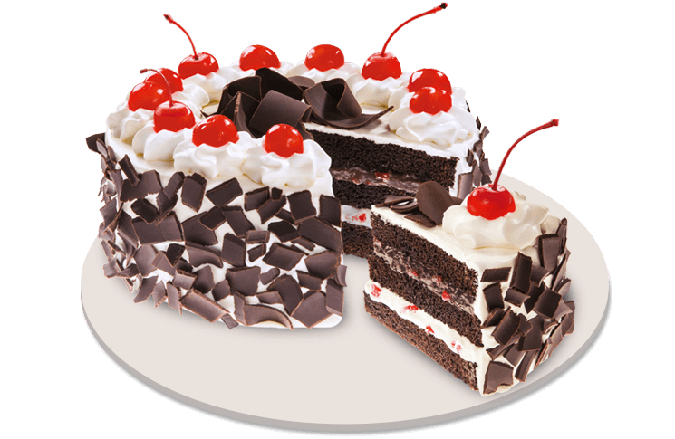 |  | Black Forest
 |  | Layers of decadent, moist chocolate fudge cake layered with fluffy cream and delectable chocolate cherry filling, topped with chocolates and cherries |  |  | 8 in. | $300.00
 |  |  |  |  | 10 in. | $330.00
 |  |  |  |  | 12 in. | $360.00
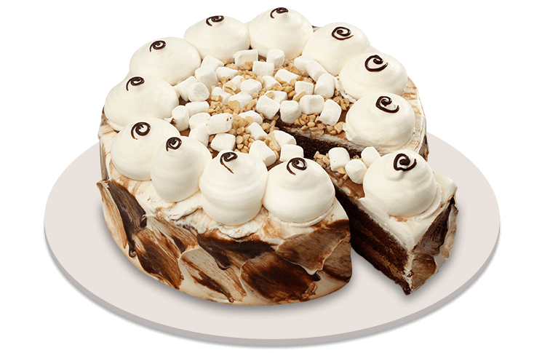 |  | Rocky Road
 |  | A chocolate chiffon cake, filled with creamy chocolate icing, and infused with the perfect balance of crunchy cashew nuts and soft vanilla mallows |  |  | 8 in. | $300.00
 |  |  |  |  | 10 in. | $330.00
 |  |  |  |  | 12 in. | $360.00
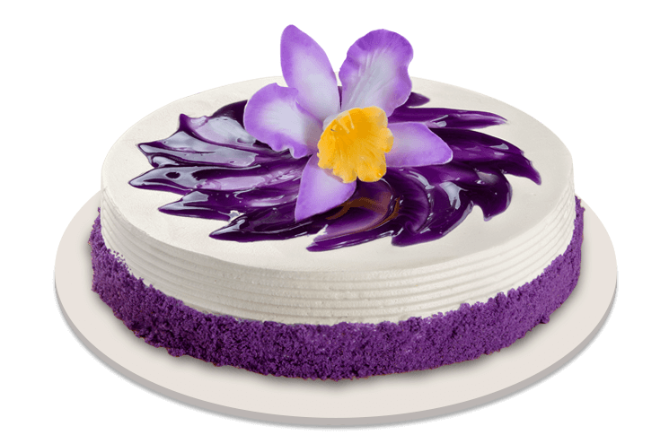 |  | Ube Bloom
 |  | Soft ube chiffon cake made with real ube halaya filling. Coated with white frosting and with ube crumble on the side. Topped off with a flower accessory and embellished with ube glaze. |  |  | 8 in. | $300.00
 |  |  |  |  | 10 in. | $330.00
 |  |  |  |  | 12 in. | $360.00
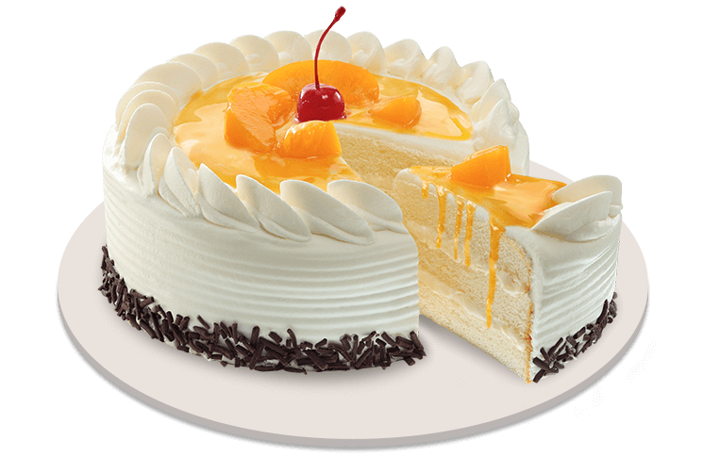 |  | Peach Mango Symphony
 |  | Melt-in-your-mouth vanilla cake with mango mousse filling infused with cheese to give it a delicious sweet and salty taste. Topped with peaches and embellished with grated chocolate. |  |  | 8 in. | $300.00
 |  |  |  |  | 10 in. | $330.00
 |  |  |  |  | 12 in. | $360.00
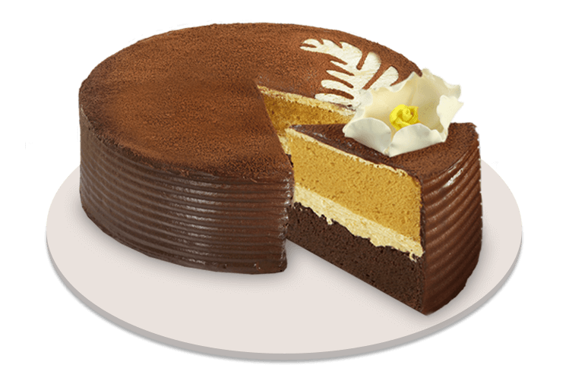 |  | Cappuccino Crème
 |  | A coffee cake with coffee liquor cream filling layered between fluffy chocolate and mocha chiffon cakes. Wrapped in milk chocolate cream, with cocoa powder. |  |  | 8 in. | $300.00
 |  |  |  |  | 10 in. | $330.00
 |  |  |  |  | 12 in. | $360.00
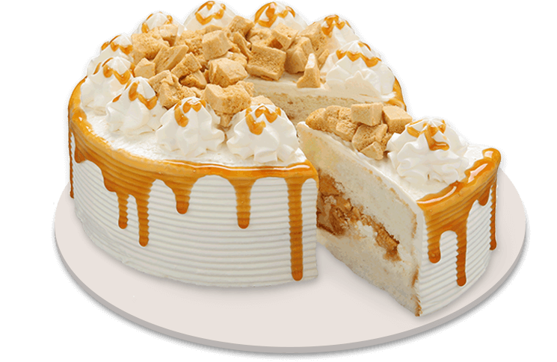 |  | Caramel Crunch
 |  | Tempting layers of cream cake topped and filled with delicious honeycomb caramel |  |  | 8 in. | $300.00
 |  |  |  |  | 10 in. | $330.00
 |  |  |  |  | 12 in. | $360.00
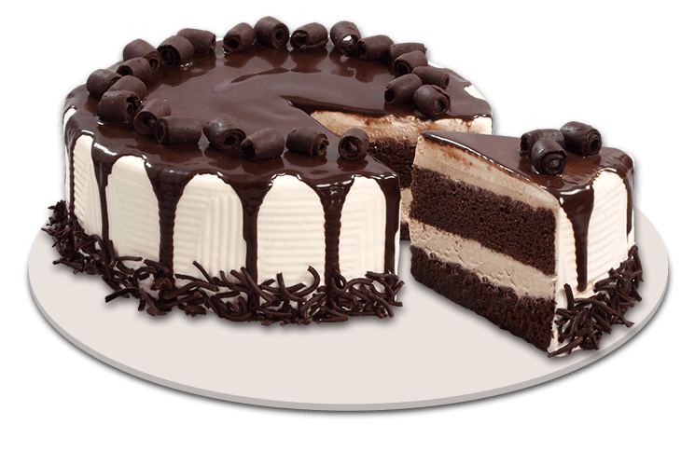 |  | Tiramisu Meltdown
 |  | Two-layer cake of choco chiffon and cream cheese with a hint of coffee liquor |  |  | 8 in. | $300.00
 |  |  |  |  | 10 in. | $330.00
 |  |  |  |  | 12 in. | $360.00
<9292 Город, улица, номер дома> | номер телефона > <Адрес сайта>

